TAKE HOME TEST

GROUP - 1

By Adharsh Sundaram Soudakar (23796349)

**Question 1: Minimal Viable Products**

1) To create a minimal viable product, we followed a simple strategy of proper communication amongst ourselves and the clients. Proper communication has proven to be very important through all stages of the project, whether it was between us and the clients or amongst ourselves.

When we didn’t understand what the client requested, we set up additional meetings. For instance, in the very early stage of the project (week 2), we requested the client for an in-person meeting as we were stuck and couldn’t start working. This in-person meeting cleared a lot of doubts that we initially had, problems / doubts that stopped us from starting the project. I could categorise this as the act of active listening, one of the cornerstones of effective communication: we demonstrated all the qualities/skills pertaining to active listening, such as clarify and reflect, share and summarise and, pay attention without judgement.

2) One success and failure that we experienced when producing a viable product is discussed below. We maintained proper documentation of all the activities that we performed. Any meeting that was held always had a meeting minute taken by at least one person. We switched the responsibility of documenting to a different team member weekly. This helped us view the project from different perspectives, as no two human beings think the same way. Any deviation from the plan could be recognised if all parts of the project are documented, it is similar to journaling where a person reflects on what he/she has done. The act of documenting progress helped us stay on course and always on the right trajectory to complete the project.

A failure as a team we encountered was improper task allocation. Not all team members were involved in the technical side of the project, and some members were not involved in the documenting / organising side. Although real world projects operate this way, as we were all students of the same course, it is ideal that we all had a technical contribution to the project.

**Question 2: Team Software Development**

A pull request can be said as a method to propose changes to a codebase in a collaborative software development. It helps to notify other members of the team of any changes that were pushed to a certain branch.

Pull requests can be used for reviewing code. It allows all members to review changes before they are merged into the main branch. They also serve as a record of changes, meaning they serve as documentation providing a history, which would help in the future. Pull requests enable multiple people to work on different features or bug fixes simultaneously, ensuring quality as changes are tested and reviewing before integration.

A good process of performing a pull request involves (this is how I did my PR):

* Creating a branch first, this would isolate the individual’s work from the main branch, therefore easier management.
* After creating a branch, make the necessary changes or fix the bug, once that is done commit the changes and push to the created branch.
* Next would be to open a pull request with proper / clear description of the changes. Also, request review from specific or all team members, this serves as a crucial step as this would help with either clearing the issue or require further changes.
* Penultimately, run all automated tests and after a successful pass on all tests, merge the changes into the main branch.
* The final step would be to communicate the merged changes’ impact to all team members.

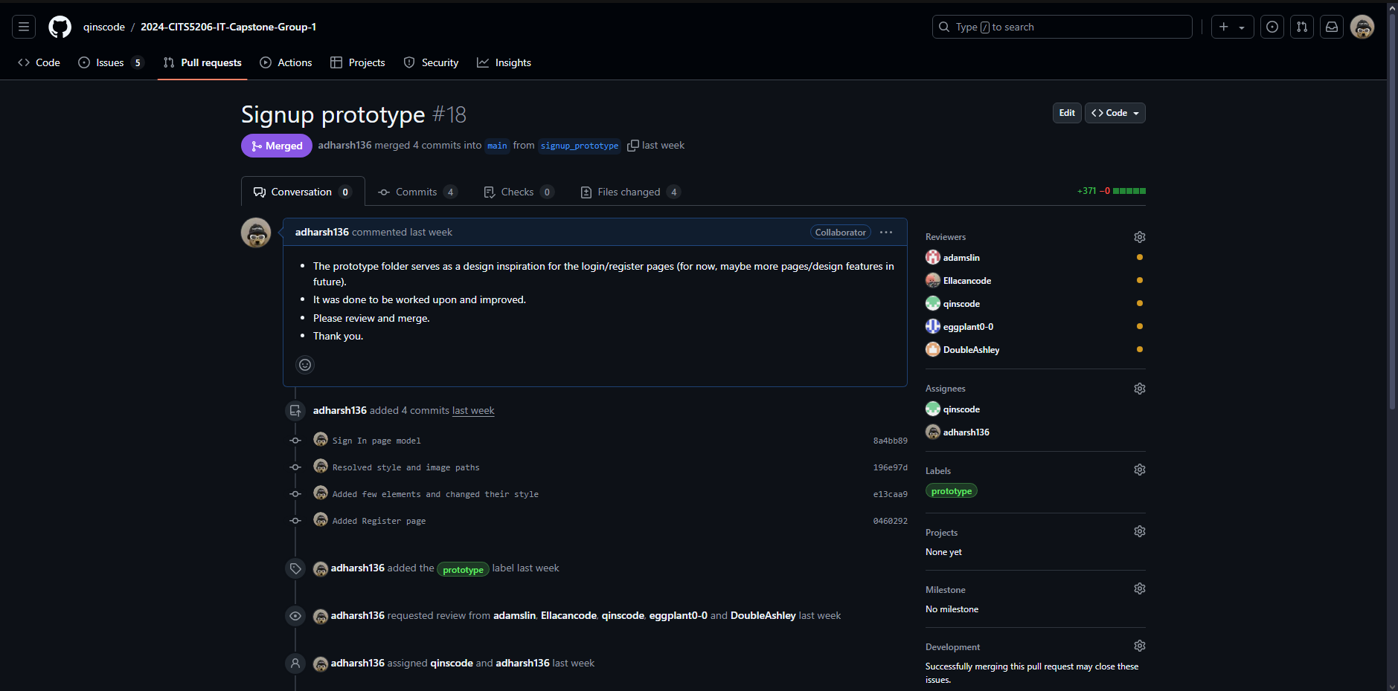

Fig. [My pull request](https://github.com/qinscode/2024-CITS5206-IT-Capstone-Group-1/pull/18)

**Question 3: Information Technology Ethics (Good and Harm)**

1) The potential benefit associated with our project is accessibility of information. Our project is the development of an efficient Curriculum Management portal that enables staff to make changes to the curriculum of the courses offered by the University. This helps future students understand the course prerequisites, requirements, outcome and many other attributes. It also helps past students come back to the curriculum page to verify their course outcomes, when applying for jobs or explaining the knowledge gained during an interview. Additionally, it helps staff clear any doubts from incoming / new students.

Possible risk associated with our project is misinformation. As the portal allows staff to make changes to the course curriculum, any mistake could result in students being misinformed. This would affect the students’ expectations of the course and the reputation of the University. The University could face legal problems, as any wrong information on the course page is considered a serious violation of its integrity.

2)

a. The two principles that I think applies to the given scenario are “honesty” and “competence”.

b. The use of AI to generate code goes against the company’s code of conduct and the fact that the person hid it from the manager, breaks this principle. The use of AI to complete a task, removes the purpose of an employee and therefore his ability to think, create and develop. To complete a task with AI questions, an employee’s competence and his place in the company.

c. The ethical course of action would be immediate termination of the IT professional as they have broken the company’s code of conduct. They may also face legal actions if the patients’ medical records were fed into the AI code generating tool “CoPilot”, as it would not only could affect the hospital but also the patients. In addition, the employee may have to pay for the damages that the data leak into the AI could have caused, or face jail time.

**Question 4: Cybersecurity**

a.

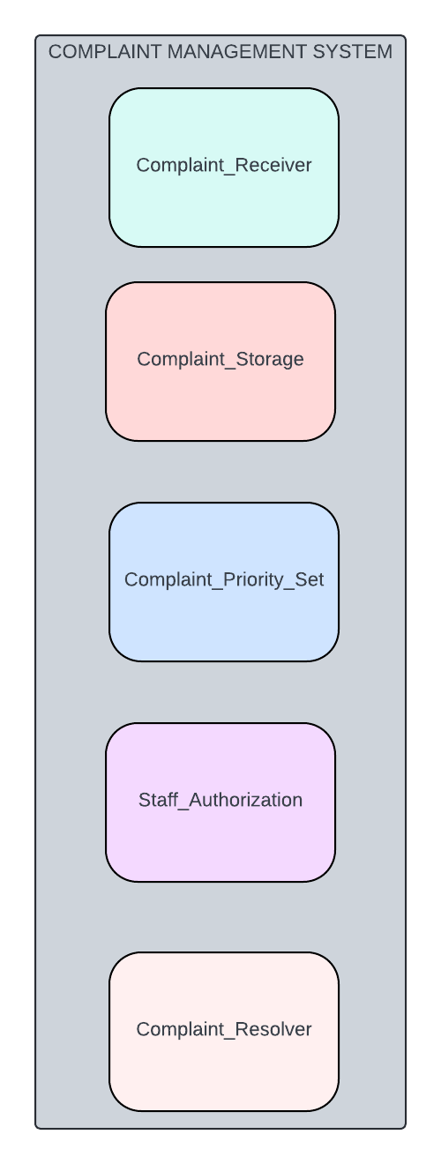The requirements identified are a “Complaint_Receiver” component that receives complaints (let us assume this component processes the complaint in a JSON format), a “Complaint_Storage” component that stores all the complaints that were received, a “Complaint_Priority_Set” component that prioritises the complaints based on their urgency, a “Staff_Authorization” component that authorises the staff who investigate and resolve the complaints and a “Complaint_Resolver” component that lets the authorised staff to perform certain actions that helps them ultimately to resolve the complaints.

The two assets that are of high priority are Complaint_Storage and Staff_Authorization. The complaint storage component stores important information such as the patient number and staff number. The Staff_Authorization component authorises the staff that will not only be able to view sensitive information but also make decision with them.

b. The key security threats for the Storage asset are database’s credentials obtained through social engineering, data breaches from human error (weak passwords, password sharing, erasure of data), and Denial of Service attacks. Of all these stated threats, Denial of Service attack is the highest priority threat as they can be very expensive, the whole system would not work as large number of fake requests flood the system. For the Authorization asset, the security threats are Injection attacks by a hacker, poor handling of login credentials by authorised personnel, and XSS (Cross-site scripting). The highest priority threat would be Injection attacks, as poor security measure could result in attack strings that execute and reveal not one but all the credentials.

c. To mitigate the DoS attack, proper firewalls could be set in place that will weed out bad requests, thereby blocking further requests from the same IP address. These firewalls could be deployed in two layers, one in the cloud/physical storage that stores the complaints and one on the web application that receives these complaints. Mitigating injection attacks involves following proper coding practices which involves concepts such as input sanitizations in forms and also run regular vulnerability tests to identify new system vulnerabilities.